**1. Which are the top three variables in your model which contribute most towards the probability of a lead getting converted?**

Ans: Total time spent on website

Lead Add Form from Lead Origin

LeadSource_Welingak Website  
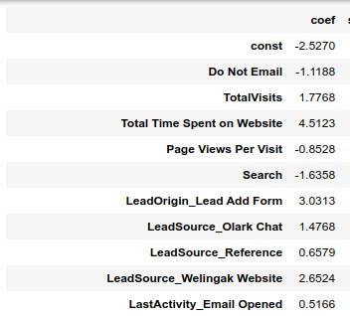  
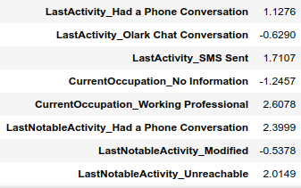

**2. What are the top 3 categorical/dummy variables in the model which should be focused the most on in order to increase the probability of lead conversion?**

Ans: From the screenshot above top3 are:

1. Lead Add Form from Lead Origin
2. LeadSource_Welingak Website
3. CurrentOccupation_Working Professional

**3. X Education has a period of 2 months every year during which they hire some interns. The sales team, in particular, has around 10 interns allotted to them. So during this phase, they wish to make the lead conversion more aggressive. So they want almost all of the potential leads (i.e. the customers who have been predicted as 1 by the model) to be converted and hence, want to make phone calls to as much of such people as possible. Suggest a good strategy they should employ at this stage.**

Sol:  
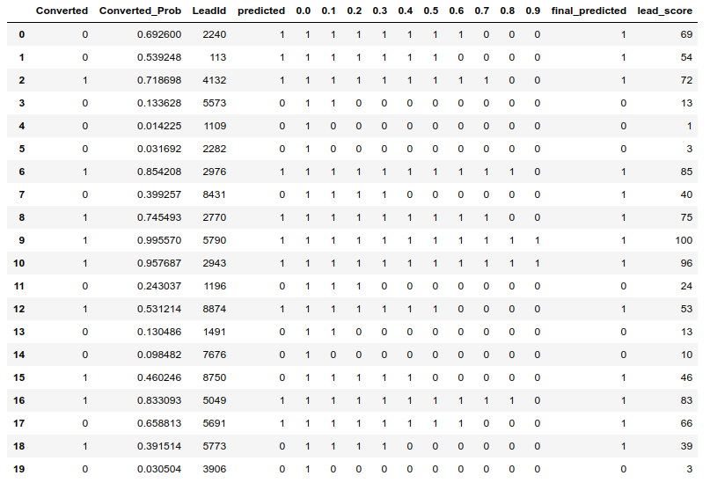

From the above image, in order to increase the sales the company should contact the leads which has conversion probability(value=1) under a cut off 0.3 i.e consider **0.2 with row numbers 0,1,2,6,7,8,9,10,12,15,16,17,18**

**4. Similarly, at times, the company reaches its target for a quarter before the deadline. During this time, the company wants the sales team to focus on some new work as well. So during this time, the company’s aim is to not make phone calls unless it’s extremely necessary, i.e. they want to minimize the rate of useless phone calls. Suggest a strategy they should employ at this stage.**

Sol: Now the sales team should concentrate which have conversion probability under 0.7.